**Q9. Weather Observation Station 4**

Find the difference between the total number of CITY entries in the table and the number of distinct CITY entries in the table.

The STATION table is described as follows:

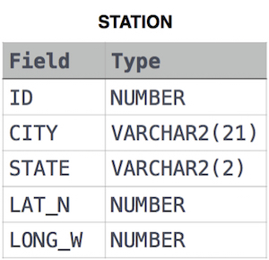

Ans.

SELECT COUNT(*)-COUNT(DISTINCT(CITY)) AS DIFF

FROM STATION